**EXERCISE NO:**11

**REGISTER NO:**1518102072

**DATE:**21.11.20

**AIM**:

To write a python program obtain Greatest Common Divisor (GCD) of two given numbers.

**PROGRAM:**

def gcd(a,b):

if(a==0):

return a

if(b==0):

return b

if(a==b):

return b

if(a>b):

return(gcd(a-b,b))

else:

return gcd(a,b-a)

a=int(input("Enter first number:"))

b=int(input("Enter second number:"))

GCD=gcd(a,b)

print("GCD is:")

print(GCD)

**LINK:**

[**http://103.53.53.18/mod/vpl/forms/submissionview.php?id=326&userid=1686**](http://103.53.53.18/mod/vpl/forms/submissionview.php?id=326&userid=1686)

**OUTPUT:**

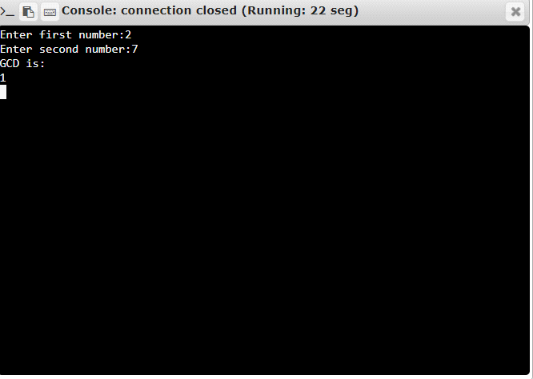

**RESULT:**

Thus the program is successfully executed and the output is verified.